**Machine Learning and Evolutionary Approach for Alzheimer’s disease detection**

B.Tech Computer Science & Engineering

# Maharaja Agrasen Institute of Technology (GGSIPU)

**Trojan Horse**

**S. P. Pradhyumna – 08414802716**

**Shubham Goyal – 10314802716**

**Karan Singh – 41014802716**

**Mentor – Mr. Moolchand Sharma**

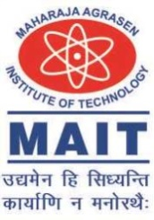

Maharaja Agrasen Institute of Technology, PSP Area,

Sector – 22, Rohini, New Delhi – 110085